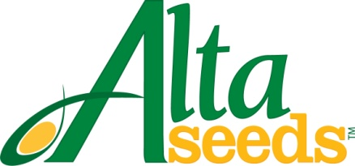

FOR IMMEDIATE RELEASE CONTACT: Barry Lubbers, Alta Seeds – (806) 622-9010
Adam Buckallew, Duff Dynamic Marketing – (816) 891-8845

Alta Seeds Announces Distribution Agreement
with Right Coop Association

AMARILLO, Texas – Kansas grain and forage sorghum growers have new seed options thanks to a recently signed distribution agreement between Alta Seeds and Right Cooperative Association (RCA). Alta Seeds is the premium seed brand of Advanta US, the leading provider of sorghum genetics in North America. RCA, based in Wright, Kan., services farmers in southwest Kansas.

“As the nation’s top sorghum producing state, Kansas is an important market for Alta Seeds and our agreement with Right Cooperative Association improves the availability of our hybrids in that territory,” says Barry Lubbers, U.S. sales manager for Alta Seeds. “As a new brand, we will continue to build our distribution network in additional regions with the help of quality partners such as RCA.”

RCA will offer the full Alta Seeds line-up of forage and grain sorghum hybrids, including the highly productive brachytic forage sorghums. Sorghum is well-suited to Kansas because it is highly drought tolerant and handles hot, dry summers better than corn.

“We were interested in adding Alta Seeds to our existing lineup because of the brand’s focus on heat and drought tolerance,” says Gary Jorgensen, RCA seed sales manager. “Grain and forage sorghum are a perfect fit for our region because of limited water availability. Due to the harsh droughts we’ve seen recently and increasing interest in sorghum, we felt it was perfect timing to begin this partnership.”

For more information visit: www.AltaSeeds.com or www.rightcoop.com. Growers can contact an RCA representative at 800-794-8819.

###

About Alta Seeds
Alta Seeds is a brand of Advanta US, an operating unit of Advanta. Advanta is an India-based global seed business that combines proprietary crop genetics and plant breeding capabilities with biotechnology to produce high quality seed products and solutions for its customers around the world. Advanta is a member of the UPL group of companies.

