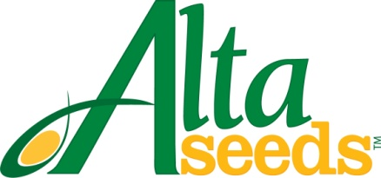

FOR IMMEDIATE RELEASE CONTACT: Barry Lubbers, Alta Seeds – (806) 622-9010
August 27, 2013 Adam Buckallew, Duff Dynamic Marketing – (816) 891-8845

Alta Seeds Announces New Customer Service and Technical Lead

AMARILLO, Texas – Alta Seeds, the premium seed brand of Advanta US, announces the hiring of Kelley Schlabs as customer service and technical lead. Schlabs will manage all incoming customer communications, including technical questions, requests and orders.

“We’re committed to providing our customers with the best seed and service possible and that starts with good communication,” says Barry Lubbers, Alta Seeds director of sales. “This is a relationship business – exceptional customer service and support is crucial to us. Kelley shares this belief and is an excellent addition to our team.”

In addition to her customer service duties, Schlabs will be responsible for supporting the Alta Seeds sales staff with order entry, sales reports and seed shipments. She will assist with field tours, dealer meetings and distributor supply management.

Schlabs has over five years of experience working in the agricultural industry including positions with Cone Grain Elevator and Dimmit Feed & Supply. Most recently she worked in sales and supplier relations for Micro Beef Technologies. Schlabs earned a degree in animal science from Texas Tech University in 2009.

Alta Seeds provides U.S. growers with the latest technology and advanced genetics in grain and forage sorghum. The Alta Seeds product line-up is selected from the vast germplasm resources of Advanta, an international leader in the research, development, production and sales of sorghum.

For more information visit: www.AltaSeeds.com

###

About Alta Seeds
Alta Seeds is a brand of Advanta US, an operating unit of Advanta. Advanta is an India-based global seed business that combines proprietary crop genetics and plant breeding capabilities with biotechnology to produce high-quality seed products and solutions for its customers around the world. Advanta is a member of the UPL group of companies.

