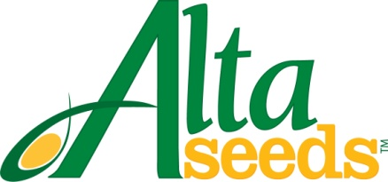

FOR IMMEDIATE RELEASE CONTACT: Barry Lubbers, Alta Seeds – (806) 622-9010
August 5, 2013 Adam Buckallew, Duff Dynamic Marketing – (816) 891-8845

Alta Seeds Introduces New Brachytic Forages
to Expand Range of Use & Add Versatility

AMARILLO, Texas – The most advanced genetics in sorghums for forage are now available to growers and producers in new geographies. The Alta Seeds brand from Advanta US is introducing new hybrids with the unique brachytic dwarf trait that offer early maturity for greater versatility. This opens up a number of options for growers including: planting in areas with shorter growing seasons, double-cropping and as a replacement crop for failed corn.

The brachytic dwarf trait reduces the distance between leaves (internodes) on a sorghum plant resulting in a short, stout plant that stands well and produces yields equal to taller plants. The new, quicker-maturing brachytic forages from Alta Seeds also feature the Brown Midrib 6 trait (BMR-6) for nutritional analysis equal to or greater than corn silage.

“Our new shorter season hybrids extend the usefulness of brachytic forages to benefit growers, dairymen and beef producers in northern areas who couldn’t grow our full-season brachytic hybrids,” says Barry Lubbers, U.S. sales manager for Alta Seeds. “Additionally, the shorter maturities of these hybrids make them a viable option for growers interested in double-cropping or as an emergency forage for farmers looking to replant.”

Capitalizing on the 40-year germplasm base built by the legacy seed companies of Advanta US, senior sorghum breeder Vicente Trucillo and his breeding team developed the brachytic dwarf BMR forages for commercial use in the United States and Argentina. Advanta has more than 20 breeding locations and labs around the world that are working to develop the hybrids represented in the Alta Seeds product portfolio.

“Since we introduced the brachytic dwarf trait in sorghums for forage, it has become increasingly popular with growers,” says Trucillo. “Our brachytic sorghum hybrids feature leaf spacing of about an inch and a half to two inches versus every six inches on conventional forage sorghums. This results in a compact plant that produces multiple tillers and resolves the lodging issues of taller plants. Our new brachytic dwarf hybrids will feature these same attributes, packaged in a hybrid that can reach maturity faster, offering increased versatility and usefulness.”

The new brachytic dwarf hybrids are expected to be available for purchase this winter for the 2014 growing season.

For more information visit: www.AltaSeeds.com

###

About Alta Seeds
Alta Seeds is a brand of Advanta US, an operating unit of Advanta. Advanta is an India-based global seed business that combines proprietary crop genetics and plant breeding capabilities with biotechnology to produce high quality seed products and solutions for its customers around the world. Advanta is a member of the UPL group of companies.

