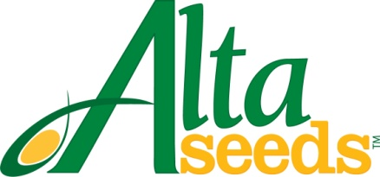

FOR IMMEDIATE RELEASE CONTACT: Barry Lubbers, Alta Seeds – (806) 622-9010
Adam Buckallew, Duff Dynamic Marketing – (816) 891-8845

Alta Seeds Announces Distribution Agreement
with Eastern Colorado Seeds, LLC

AMARILLO, Texas – Grain and forage sorghum growers in the Great Plains have additional seed options thanks to a new distribution agreement between Alta Seeds and Eastern Colorado Seeds, LLC (ECS). Alta Seeds is the premium seed brand of Advanta US, the leading provider of sorghum genetics in North America. Eastern Colorado Seeds, based in Burlington, Colo., has seed salesmen covering 8 states, including Colorado, Kansas, Nebraska, Wyoming, Oklahoma, Texas, New Mexico and Utah.

“Working with Eastern Colorado Seeds significantly expands the availability of Alta Seeds branded hybrids thanks to their broad range of distribution,” says Barry Lubbers, U.S. sales manager for Alta Seeds. “As a new brand, we will continue to build our distribution network with quality seed companies such as Eastern Colorado Seeds in additional states and regions.”

Eastern Colorado Seed will offer the full Alta Seeds line-up of forage and grain sorghum hybrids, including the highly productive brachytic forage sorghums. Sorghum is well-suited to the Great Plains because it is highly drought tolerant and handles hot, dry summers better than corn.

“This is a strategic alliance combining the superior genetics and production capabilities of Alta Seeds with our product knowledge and marketing throughout the heartland of the United States,” says Clay Smith, ECS owner and general manager. “We are excited to bring the Alta Seeds product portfolio to our customers. The genetic pipeline of products coming out of Alta Seeds is going to be a perfect fit for our clients. Regardless if you raise beef or dairy cattle, or you’re looking for hay, silage or even grains we now have products specific for those needs. My staff and dealer network are looking forward to working with growers on all their sorghum needs.”

For more information visit: www.AltaSeeds.com or contact an ECS representative at 866-655-7380.

###

About Alta Seeds
Alta Seeds is a brand of Advanta US, an operating unit of Advanta. Advanta is an India-based global seed business that combines proprietary crop genetics and plant breeding capabilities with biotechnology to produce high quality seed products and solutions for its customers around the world. Advanta is a member of the UPL group of companies.

