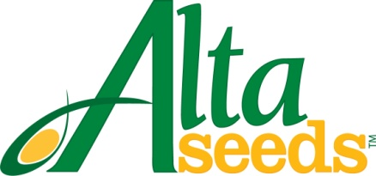

FOR IMMEDIATE RELEASE CONTACT: Barry Lubbers, Alta Seeds – (806) 622-9010
Adam Buckallew, Duff Dynamic Marketing – (816) 891-8845

Alta Seeds Announces Distribution Agreement
with Ohlde Seed Farms

AMARILLO, Texas – Grain and forage sorghum growers in Kansas have new seed options thanks to a recently signed distribution agreement between Alta Seeds and Ohlde Seed Farms Inc. Alta Seeds is the premium seed brand of Advanta US, the leading provider of sorghum genetics in North America. Ohlde Seed is a family owned and operated company, based in Palmer, Kan., servicing farmers across the Sunflower State.

“Our agreement with Ohlde Seed Farms provides us with the means to boost the availability of our hybrids in the country’s top sorghum producing state,” says Barry Lubbers, U.S. sales manager for Alta Seeds. “We are excited to continue building our distribution network with a company that has demonstrated a long-term commitment to Kansas farmers and is focused on providing excellent service to our growers.”

Ohlde Seed will offer the full Alta Seeds line-up of forage and grain sorghum hybrids, including the highly productive brachytic forage sorghums. “We are seeing strong demand this spring for high-quality forage products due to feed shortages and high-priced grains,” says Shane Ohlde, CEO of Ohlde Seed Farms. “With the drought conditions we’ve experienced recently, our customers have seen excellent results with forage sorghum hybrids that have proved extremely important to their bottom line.”

“At Ohlde Seed, our message to our customers is ‘Surround Yourself with Your Best Choices’ and our distribution agreement with Alta Seeds improves their options by offering premium sorghum and forage seed,” says Ohlde. “Our business is modeled on being a trusted source that offers customers personalized service customized to their farm, top performing traits and genetics and the very best quality in a bag. We believe our collaboration with Alta Seeds strengthens our position in the marketplace while keeping our core values in place.”

For more information visit: www.AltaSeeds.com or contact an Ohlde Seed representative at (877) 692-4555.

About Alta Seeds
Alta Seeds is a brand of Advanta US, an operating unit of Advanta. Advanta is an India-based global seed business that combines proprietary crop genetics and plant breeding capabilities with biotechnology to produce high quality seed products and solutions for its customers around the world. Advanta is a member of the UPL group of companies.

